CODERS WITHOUT BORDERS |BIT2102 FUNDAMENTALS OF INTERNET | April 14, 2022

VMEDA WEBSITE

Virtual medical assistant



# GROUP MEMBERS

1. MARGARET GITHINJI – BIT/2022/45218
2. EMMANUEL WAITHAKA – BIT/2022/46096
3. FORTUNE BAMJI – BIT/2022/47500
4. HORRACE MUENDO – BIT/2022/50144
5. STEPHEN NJIHIA –BIT/2020/92183
6. VICTOR MUCHUI – BIT/2022/45016

# INTRODUCTION

VMedA (Virtual Medical Assistant) is a web application that intends to help users find medical assistance by connecting them to a medical practitioner or hospital in dire situations. The website currently static and displays information on what we intend to achieve.

# PROJECT LINK

<https://github.com/vmuchui/2022.03.29-VMedA.git>

# PROJECT OVERVIEW

* Home

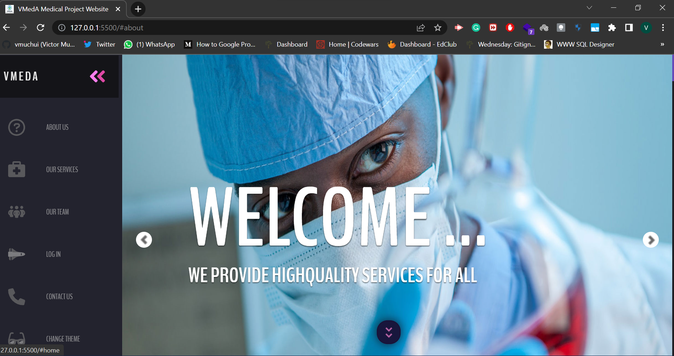

* About us

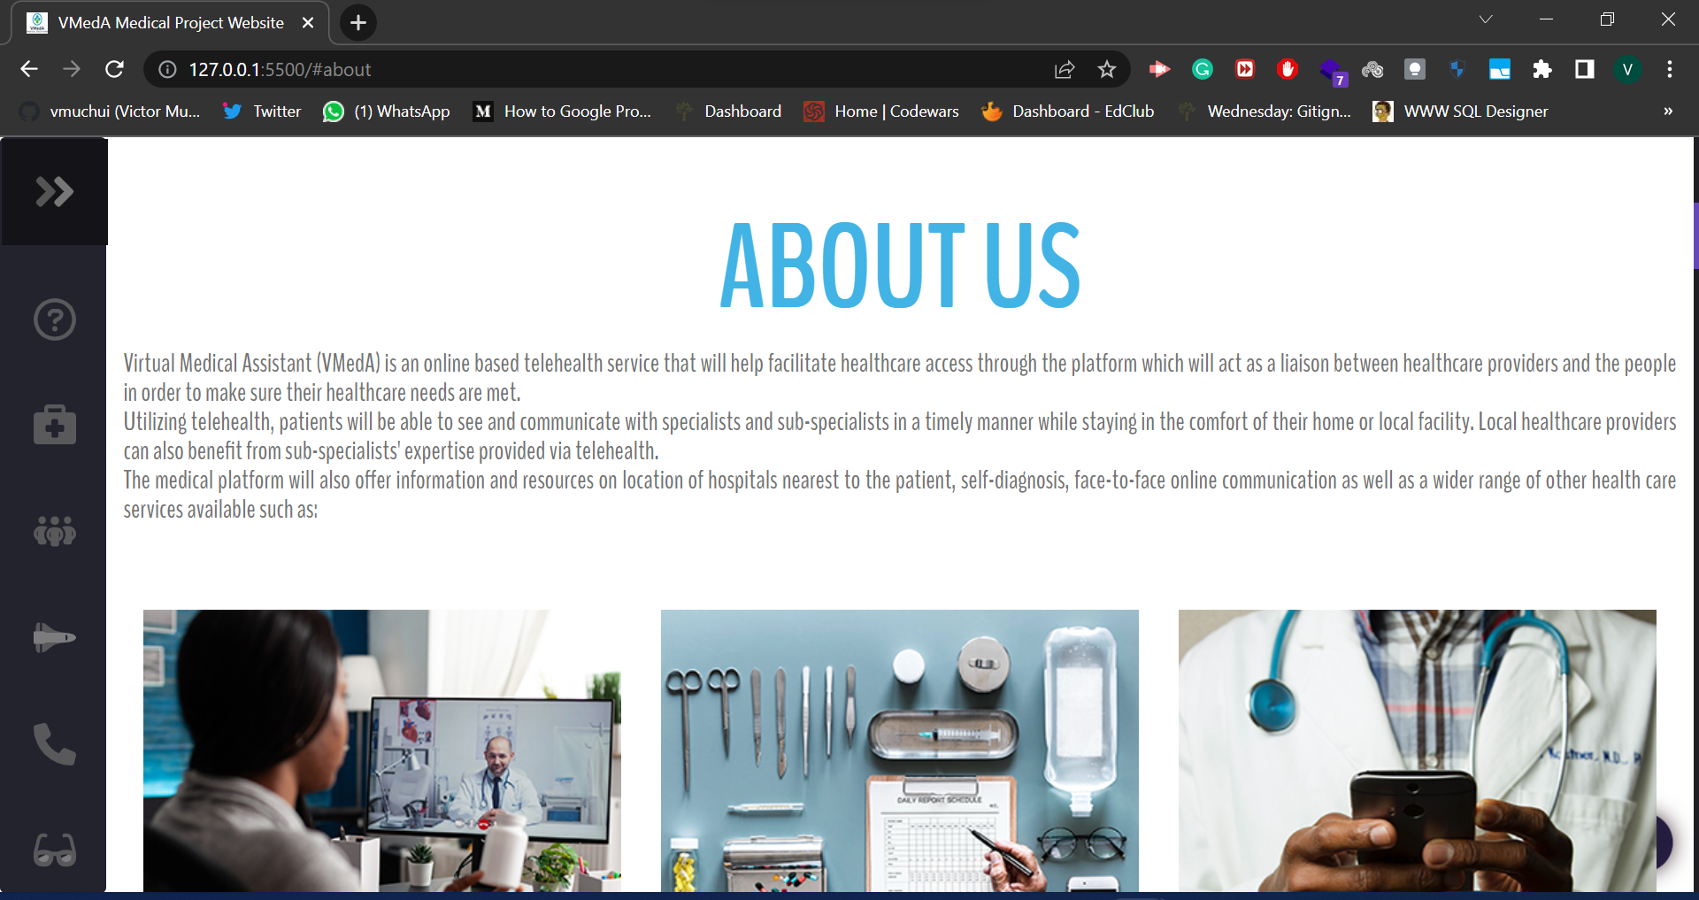

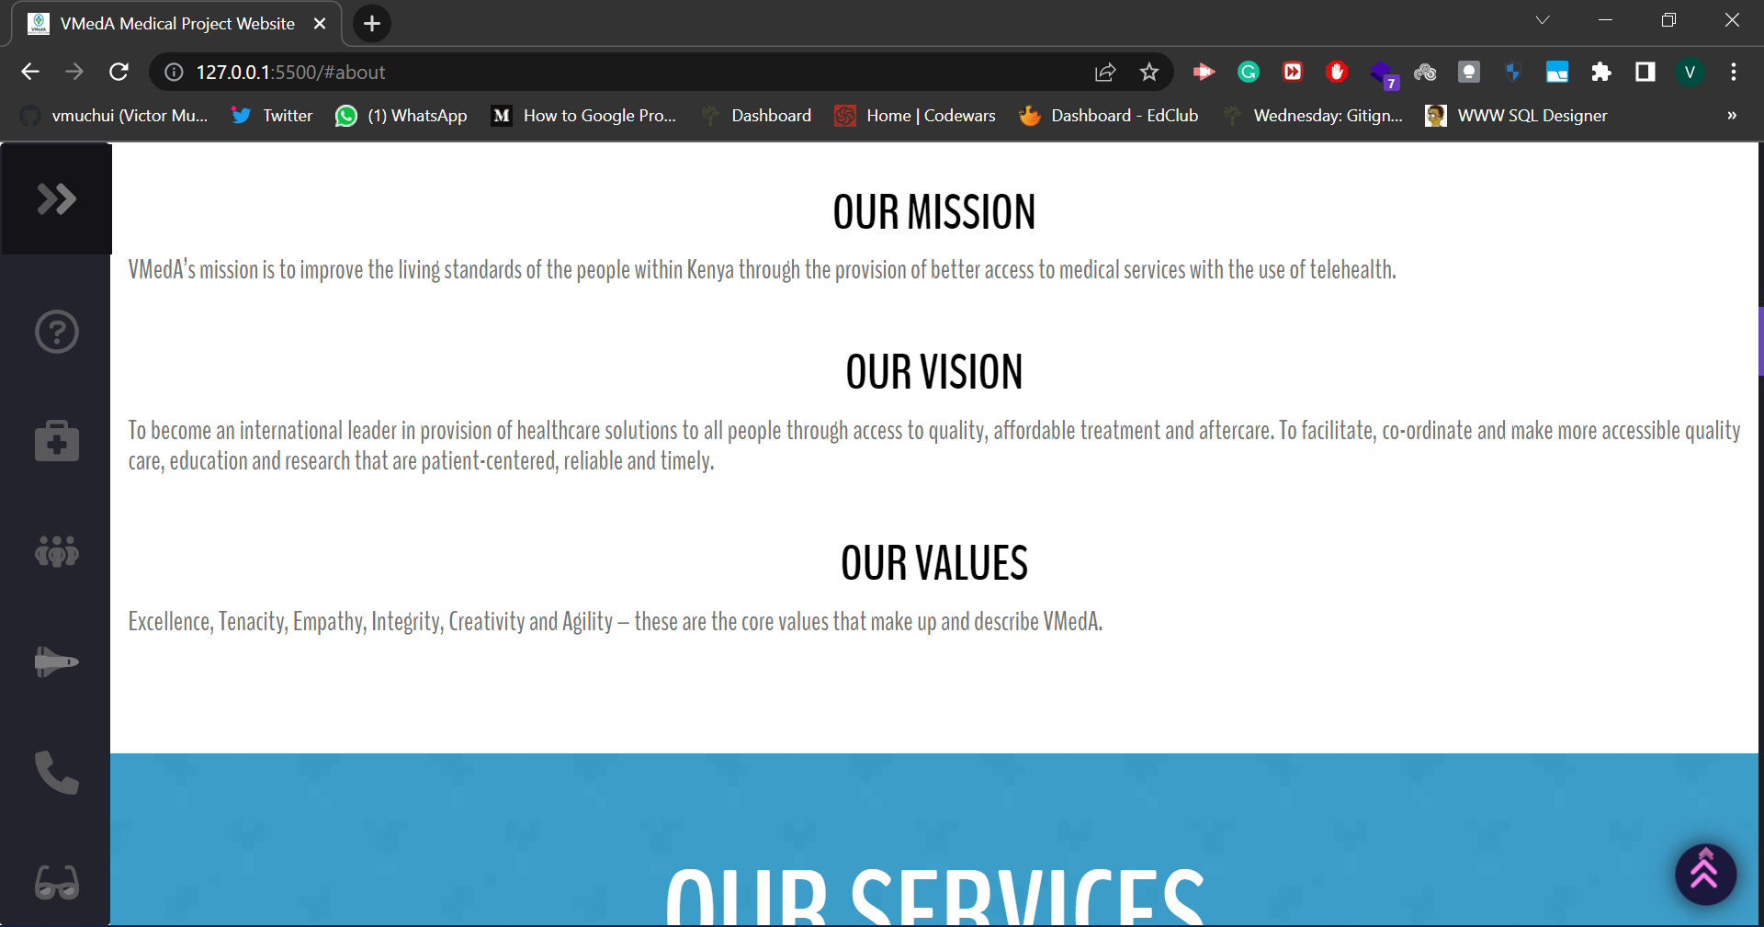

* Our services

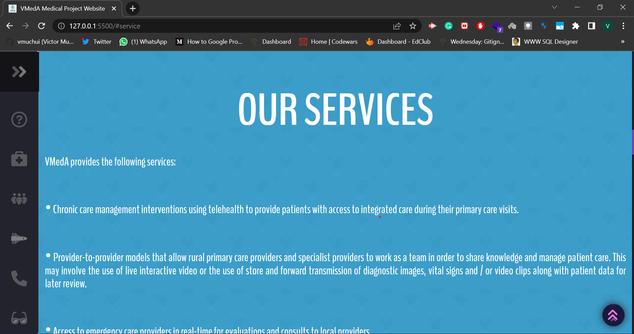

* Our team (the photos used are not the actual people involved in the project)

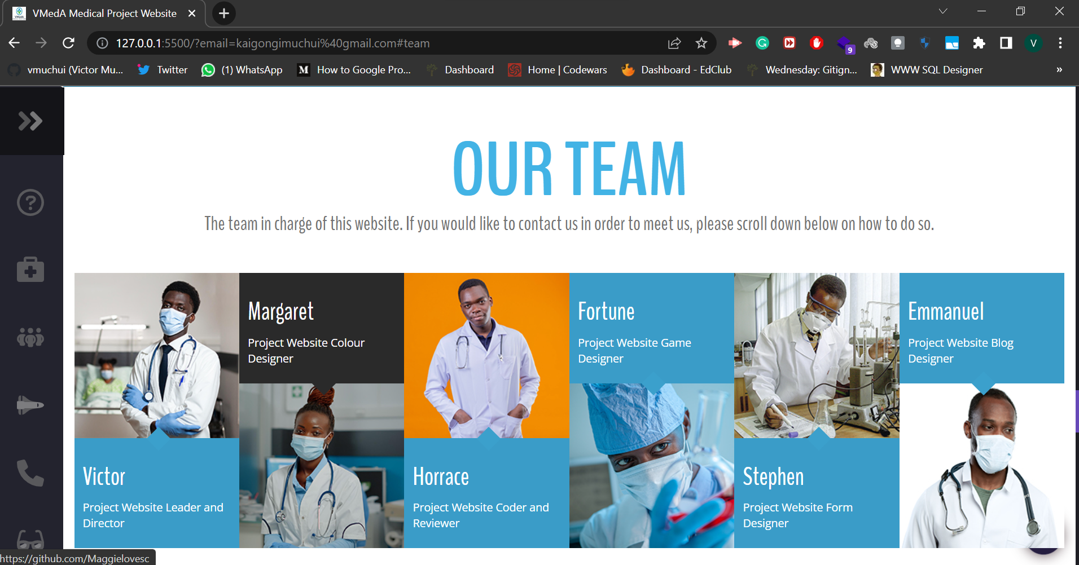

* Log in

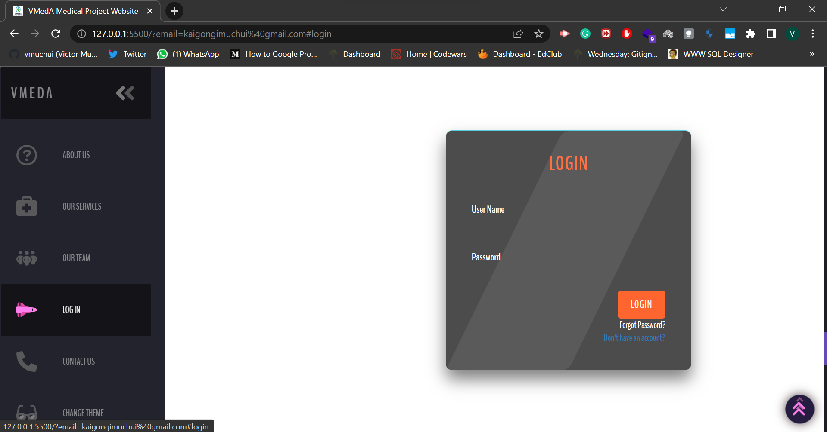

* Change navbar theme

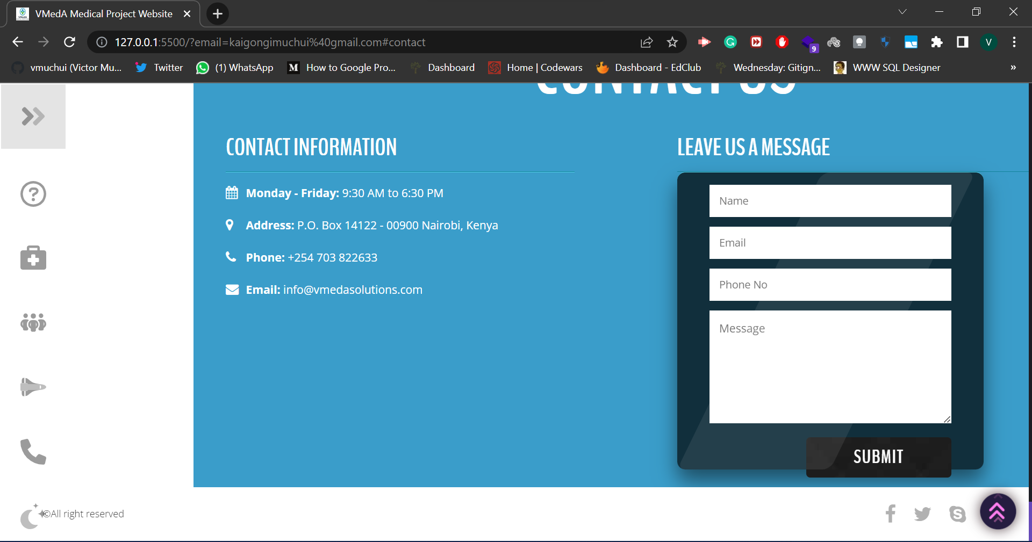

* Reset password

